Helps to evaluate the performs accuracy prediction of linear regression model, all the below three error metric are helps to find the distance between actual data point and the predicted data.

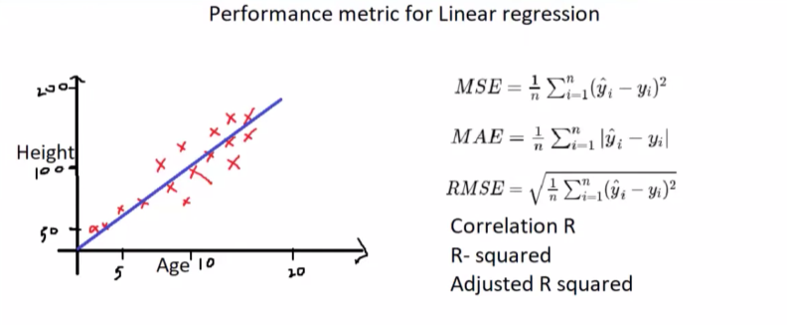
MSE: Optimal best fit line will be found by calculating mean square error. We will find the square distance between prediction data point and actual data point, in below image a dot not in x is the predicted data point, a point within the line are called actual data point, that founded sum of squared difference will be divided by mean
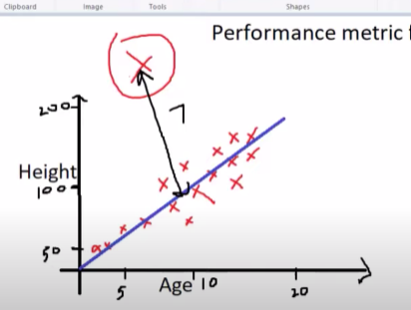
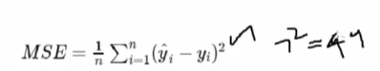
Outliers can be detected in mse.
MAE: Mean absolute error will calculate only the distance between the actual data point and predicted data point, the values will not be squared like MSE. Outliers cannot be detected in mae
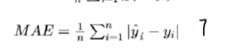
RMSE: We just find the root of the mean squared error, so outlier can be detected here.
R-SQUARED VALUE
This is also helps to see how our model performed from the average fit line. It finds the distance between actual data point and predicted point(sum of residual) and also it finds the distance between average line’s data point to actual data point(sum of total), both will be divided.
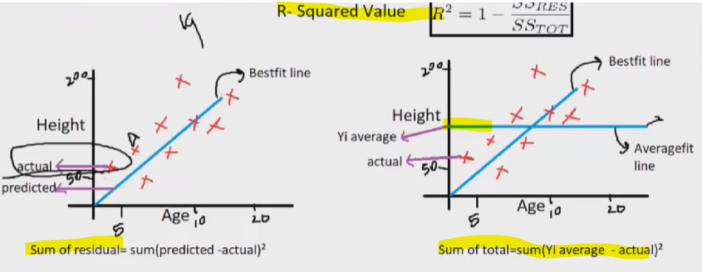
So here the best fit line will have the minimum distance errors, while average line will have bigger distance error, so this r square will tell you how our best line’s error far from average fit line’s error. So res should always be less than total, in below formula we can say that 90 variance are the when we compare best fit’s line error compare to average fit line’s error.
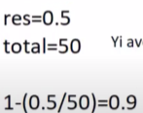

IMPORTANT NOTE: R square values should be bigger if the model’s prediction is correct. Otherwise we can say model’s prediction is not good. And also MSE/AE should be less for good prediction model.
